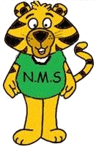
NASHWAAKSIS MEMORIAL SCHOOL
80 Main Street
Fredericton, NB E3A 1C4
Telephone: (506) 453-5421
Fax: (506) 453-3942
Website: nms.nbed.nb.ca

Mrs. Jackie Hay Ms. Elizabeth McCabe
Principal Vice-Principal

June 2024

Dear Nashwaaksis Memorial Families,
In September, we will be collecting $55.00 from each child and the teachers will purchase the school supplies. You will be able to pay this through School Cash On-Line.
You are only responsible to purchase a pair of indoor sneakers, a backpack, a lunch bag, 2 boxes of Kleenex (send one in September and one in January), ear buds/ear phones and a luggage tag with bussing/drop off & pick up information filled in and water bottle. The sneakers, backpack and 1 box of Kleenex all need to be brought to school on the first day. If you are not paying the $55 student fee online, it is due the 1st day of school.

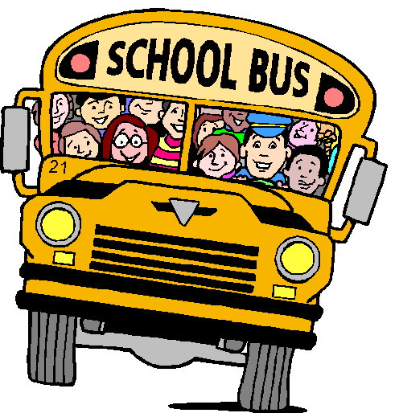
Have a safe and happy summer! We look forward to seeing you in September!

Nashwaaksis Memorial Teachers

